Ideation Phase
Empathize & Discover
Date | 21 October 2026
Team ID | SWUID2026403023
Team Members | Individual project (single member)
Project Name | StaffSync
Maximum Marks
Document Version | v1.2 (revised 27 October 2026; originally issued 21 October 2026 as v1.0)

Empathy Map Canvas:
Understand the needs, frustrations and behaviours of HR personnel, managers and employees who currently manage people-related processes manually, and who would use a centralized platform such as StaffSync.
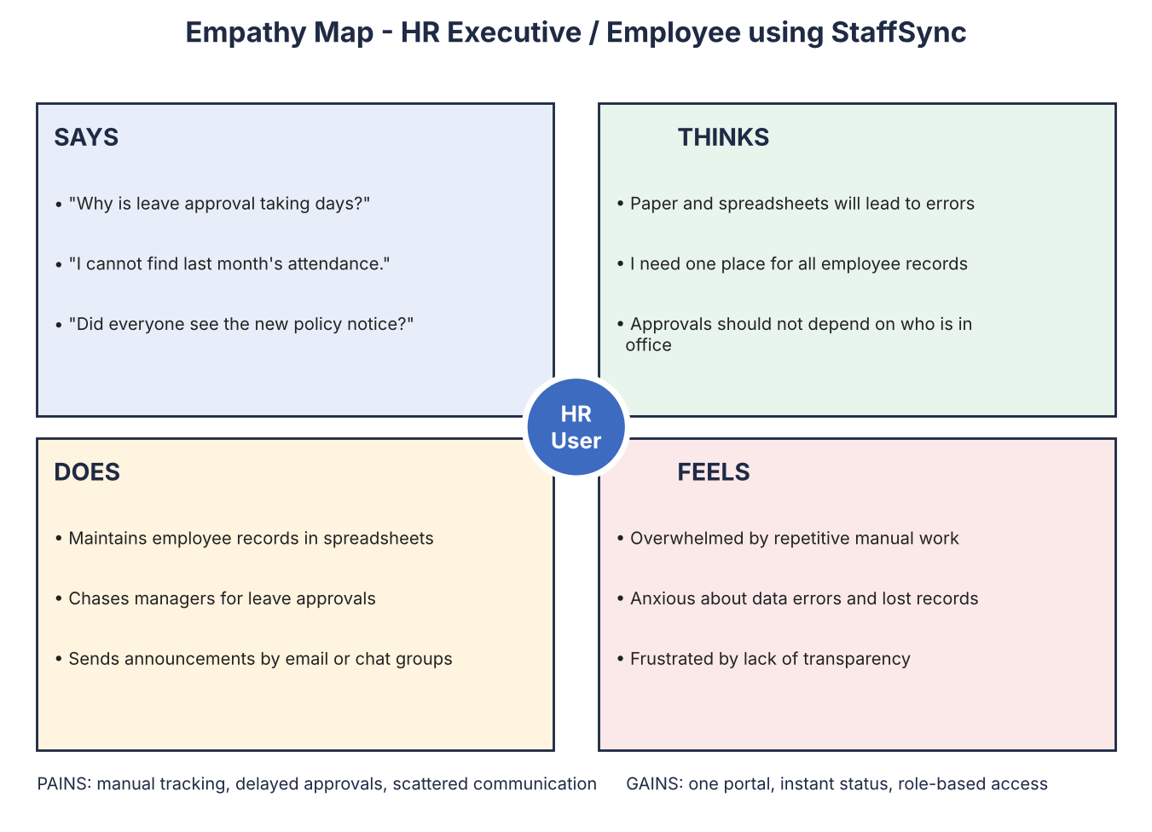
Reference: https://www.mural.co/templates/empathy-map-canvas
Empathy Map - Text Summary for All Three User Roles
The canvas above shows the HR executive. The table below records the same four quadrants, plus pains and gains, for each StaffSync role so that the findings are readable, searchable and consistent with the user stories.
 | HR Executive | Manager | Employee
Says | "Why is leave approval taking days?"  "I cannot find last month's attendance."  "Did everyone see the new policy notice?" | "Who from my team is on leave next week?"  "Which of my people still need training?" | "Has my leave been approved yet?"  "How many leave days do I have left?"
Thinks | Paper and spreadsheets will lead to errors; I need one place for all employee records. | Approvals should not depend on who is in office; I need one view of my team. | I should not have to chase anyone to know my leave status; I want to see what the company announces.
Does | Maintains records in spreadsheets; chases managers for approvals; sends announcements by email or chat groups. | Receives leave requests through chat, email or in person; assigns training informally. | Emails or asks in person to apply for leave; marks attendance on paper or a register; checks chat groups for news.
Feels | Overwhelmed by repetitive work; anxious about data errors; frustrated by lack of transparency. | Disorganized and slow to respond; unsure of team availability. | Frustrated and uncertain about plans; uninformed and disconnected.
Pains | Manual tracking, delayed approvals, scattered communication, duplicate or outdated records. | Scattered request channels; no team dashboard; no progress view for training. | No leave status or balance view; missed announcements; no record of own attendance.
Gains (StaffSync) | One portal for records, attendance and announcements; role-based access. | Single queue of team leave requests; team leave calendar; training assignment with progress tracking. | Instant leave status; self-service check-in; one place for news and assigned training.

Revision History
Version | Date | Summary of changes
v1.0 | 21 October 2026 | Initial issue.
v1.1 | 23 October 2026 | Clarified the assumption note; the Manager gains now include the team leave calendar (FR-3.7).
v1.2 | 27 October 2026 | Aligned the project overview and role/module descriptions with the current StaffSync stack and demo deployment; retained detailed design notes and planned-vs-actual distinctions.

